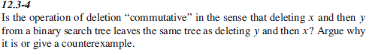



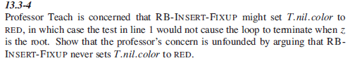

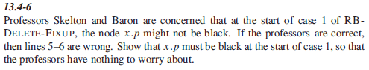

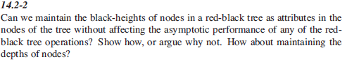

<http://sites.math.rutgers.edu/~ajl213/CLRS/Ch13.pdf>